Linux Open Hackathon
Name:Krishnakumar S
Roll no:7376252AD221
Task 1
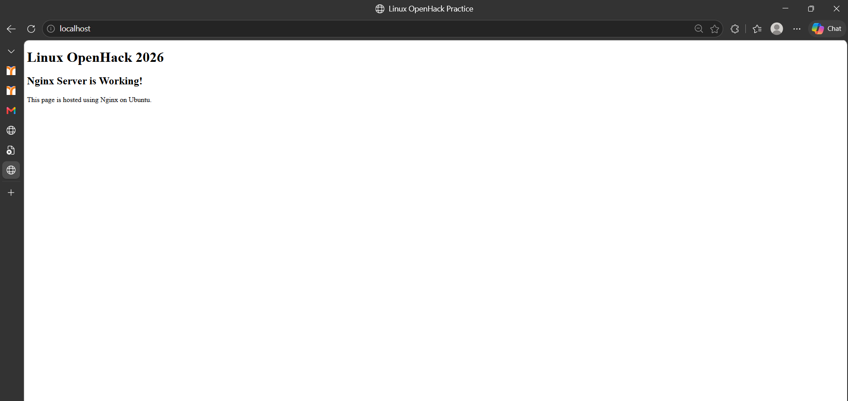
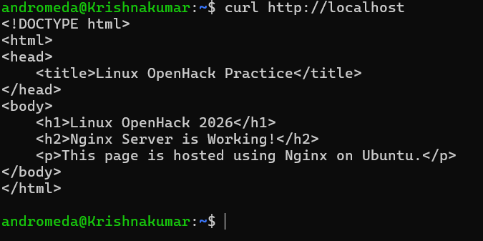
Task 2

